Microstepping Chart
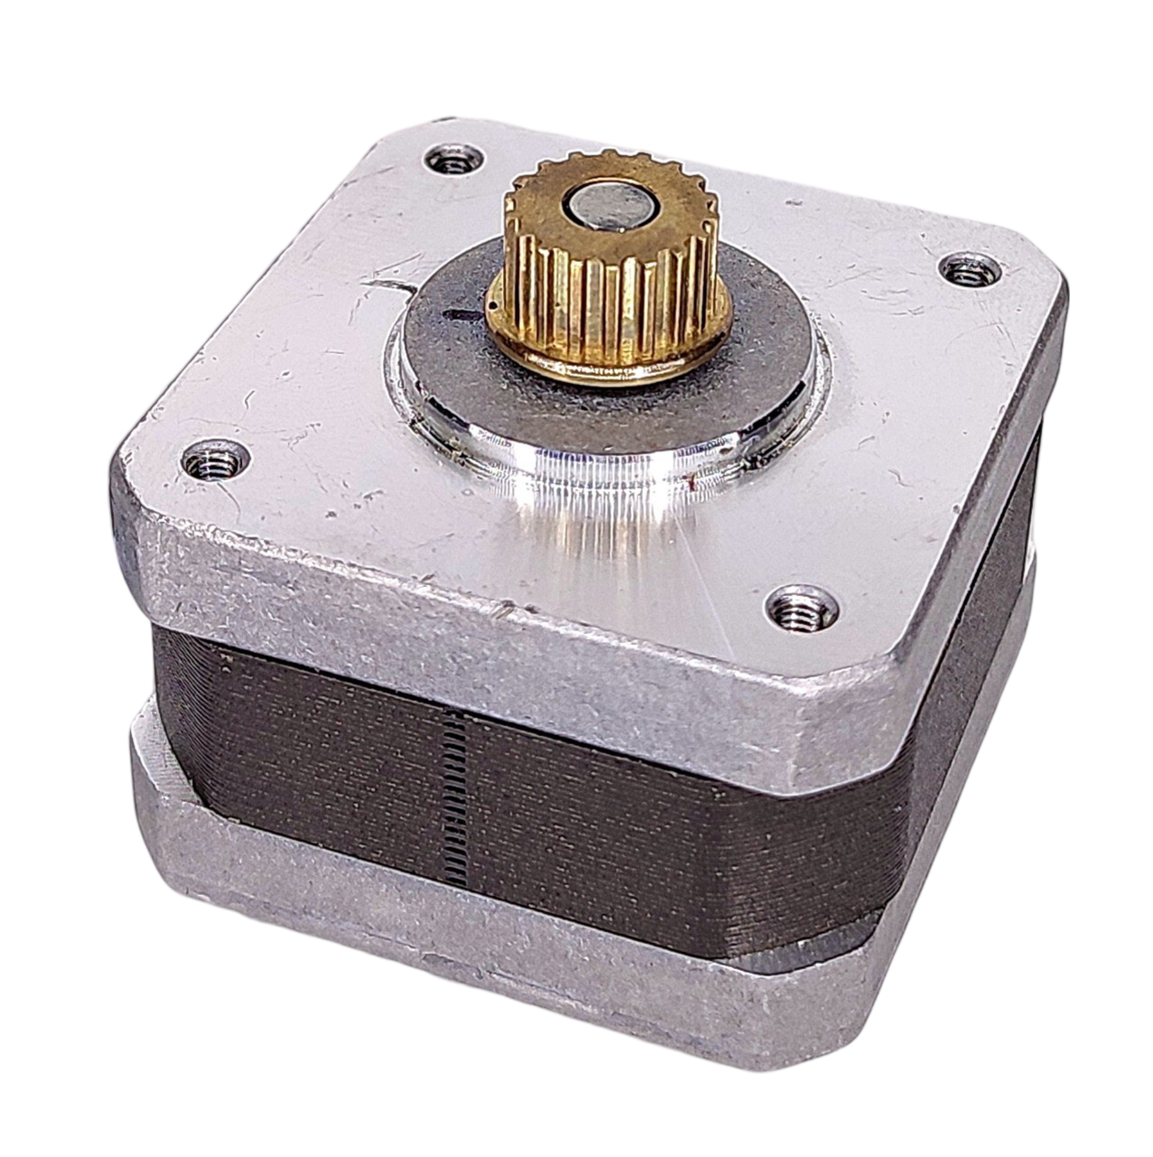
Frame Size: NEMA 17
Rated Current: DC 0.43A/Phase
Holding Torque: 0.09N·m
Step Angle (degrees): 0.9°
Phase Resistance: ~8Ω/Phase

Test Conditions:
◾ A4988 driver used for all tests
◾ Tested at 25%, 50%, 75%, and 100% of the rated current
◾ Tested with a driver supply voltage of 12V and 24V

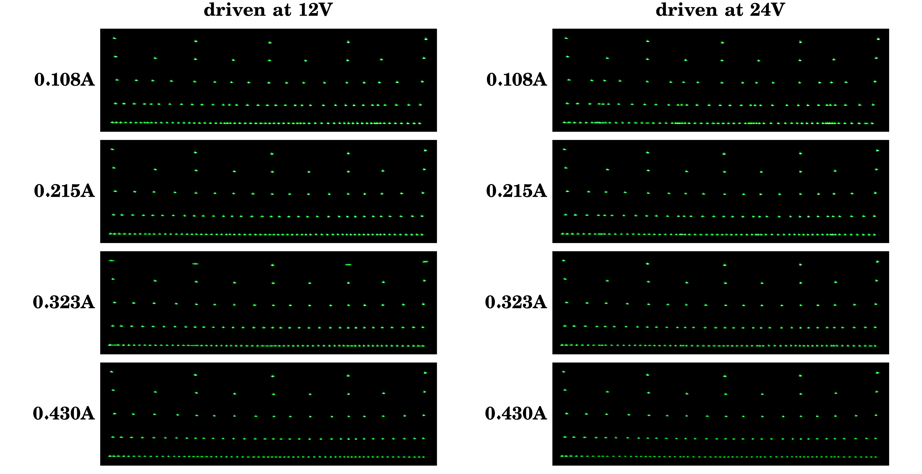

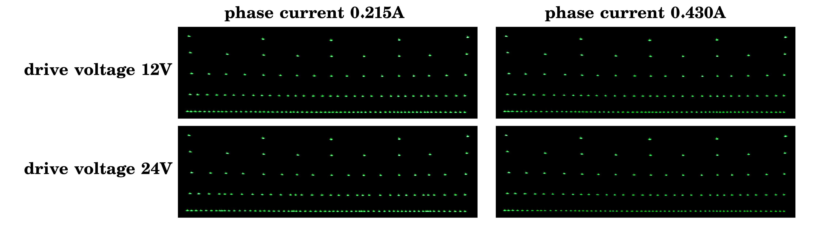
Notes:
◾ Every pattern was created at the indicated voltage and current levels by a laser galvo projector with the X-mirror actuated by the test subject. In automated fashion, a line of dots was drawn with the driver set to full steps, then the same row in half steps lined up underneath, then quarter steps, etc., all the way down to sixteenth steps.
◾ Due to the limited exposure duration of my camera, some combinations of drive current and voltage resulted in motion blur from the mirror ‘bouncing’ more than usual before settling at its intended target position. Other than in extreme cases, this should not significantly impact data accuracy.
◾ For convenient presentation of the data, all images on this chart were slightly scaled down vertically to achieve a wider aspect ratio. This does make all dots slightly oval-shaped but shouldn’t invalidate the data in any way.

